ANSWERS TO GEC MINUTES
- The base/reference paper is from 2021. Please review and confirm whether any recent work has been carried out in the same research area since then.
Aspect | Ferrario et al. (2021) | Guizzardi et al. (2021) | Spahn (2023) | Lu et al. (2022) | E-LENS (2025) | Proposed Research (Your Work)
Focus Area | Ethical requirements identification | RE-based ethical modeling | Ontology-based ethics | Responsible AI roadmap | Ethics assurance | Ethical RE for AI (end-to-end)
Ethical Principles Covered | Fairness, accountability, transparency | Ethics in RE | Ethicality concepts | High-level ethics | Ethics validation | Fairness, Privacy, Explainability, Responsibility
RE Lifecycle Coverage | Partial | Partial | Partial | Conceptual only | Partial | Full RE lifecycle (elicitation → traceability)
Measurable Ethical Metrics | No | No | No | No | Limited | Yes (fairness, explainability, privacy metrics)
Dataset-Level Evaluation | No | No | No | No | Limited | Yes (Adult, COMPAS, German Credit, Bank Marketing)
ML Model Integration | No | No | No | No | Limited | Yes (LogReg, RF, XGBoost, etc.)
Explainability Tools (SHAP/LIME) | No | No | No | No | Partial | Fully integrated
Fairness Toolkits (AIF360/Fairlearn) | No | No | No | No | Partial | Fully integrated
Validation Automation | No | No | No | No | Semi-manual | Automated via web tool
Traceability Support | No | No | Ontology only | No | Argument-based | Full traceability (Req → Data → Model → Metric)
Web-Based Tool Support | No | No | No | No | Prototype | Complete validation platform
Industry Readiness | Low | Low | Medium | Low | Medium | High (practical & deployable)
Continuous Monitoring | No | No | No | No | Limited | Yes

- The matrix of the four ethical requirements must be clearly justified.
• Explain whether and how ethical issues may arise.
• Provide clear examples (e.g., Justice vs. Equity).
• Clearly justify the rules and assumptions used for each ethical requirement.
• Explain the matrix with simple and relevant examples.

COMPLETE ETHICAL REQUIREMENTS MATRIX
Ethical Requirement | Potential Issues & How They Arise | Justice vs. Equity Examples | Rules & Assumptions | Simple Example
FAIRNESS | How Issues Arise:  1. Historical Bias: Training data reflects past discrimination  2. Proxy Discrimination: Using ZIP code as income proxy  3. Algorithmic Amplification: ML amplifies small biases  4. Fairness-Utility Tradeoff: Fairness vs. accuracy conflict | Justice (Equal Treatment):  • Everyone gets same loan approval criteria  • Same hiring test for all candidates  Equity (Equal Outcome):  • Adjust loan criteria for marginalized groups  • Different hiring thresholds to achieve diversity | Rules:  1. No discrimination on protected attributes  2. Equal opportunity for qualified individuals  3. Regular fairness audits required  Assumptions:  • Protected attributes identifiable  • Historical disadvantage exists  • Merit can be measured objectively | Loan Approval AI:  Justice: Same credit score threshold for all: discriminates against historically underbanked groups  Equity: Adjust thresholds by neighborhood poverty level : achieves fair outcomes
PRIVACY | How Issues Arise:  1. Data Re-identification: Anonymous data linked back to individuals  2. Function Creep: Data used beyond original purpose  3. Inference Attacks: AI infers sensitive information  4. Consent Fatigue: Users agree without understanding | Justice:  • Same privacy rules for everyone  • Uniform data collection limits  Equity:  • Extra privacy for vulnerable groups  • Special protections for marginalized communities | Rules:  1. Data minimization principle  2. Purpose limitation  3. k-anonymity ≥ 5  4. User consent required  Assumptions:  • Users value privacy  • Data can be sufficiently anonymized  • Purpose can be clearly defined | Health App:  Justice: Collect same data from all users : exposes vulnerable populations  Equity: Allow vulnerable users to opt-out of sensitive data collection: protects those at risk
TRANSPARENCY (EXPLAINABILITY) | How Issues Arise:  1. Black Box Problem: Complex models uninterpretable  2. Stakeholder Mismatch: Wrong explanation for wrong audience  3. Selective Transparency: Only sharing favorable information  4. Explanation Manipulation: Gameable explanations | Justice:  • Same explanation format for all users  • Standard technical explanations  Equity:  • Tailored explanations based on user knowledge  • Multiple explanation formats for accessibility | Rules:  1. Must provide meaningful explanations  2. Explanation must match model reasoning  3. Different explanations for different stakeholders  Assumptions:  • Explanations improve trust  • Users can understand appropriate explanations  • Fidelity can be measured | Medical Diagnosis AI:  Justice: Give same technical explanation to all: confuses patients  Equity: Give doctors technical details, patients simple visual explanations : appropriate understanding
ACCOUNTABILITY | How Issues Arise:  1. Responsibility Diffusion: "The algorithm decided" excuse  2. Audit Trail Gaps: Missing decision logs  3. Redress Barriers: Difficult to challenge decisions  4. Legal Loopholes: No liability for AI errors | Justice:  • Same appeal process for all  • Uniform liability rules  Equity:  • Simplified redress for disadvantaged users  • Proactive monitoring for vulnerable groups | Rules:  1. Clear responsibility assignment  2. Complete audit trails  3. Accessible appeal mechanisms  4. Regular impact assessments  Assumptions:  • Responsibility can be clearly assigned  • Logs don't compromise privacy  • Redress mechanisms are effective | Hiring AI Rejection:  Justice: Standard appeal form: disadvantages non-technical applicants  Equity: Multiple appeal channels (phone, online, in-person): ensures access for all

JUSTIFICATION & EXAMPLES
1. FAIRNESS: Justice vs. Equity in Practice
Scenario: University Admissions AI
Approach | Justice (Equality) | Equity (Equality of Outcome)
Method | Same SAT score cutoff for all applicants | Holistic review considering socioeconomic background
AI Implementation | Automatically admit above 1400 SAT | Adjust thresholds based on school quality, neighborhood
Result | Mostly wealthy suburban students admitted | Diverse student body including underrepresented groups
Ethical Issue | Perpetuates existing educational inequalities | May be seen as "reverse discrimination"
Justification | "Merit-based" but ignores unequal starting points | Acknowledges systemic barriers and seeks to correct them
Rules for Fairness:
- Group Fairness: Protected groups should have similar outcomes
- Individual Fairness: Similar individuals should have similar outcomes
- Counterfactual Fairness: Decision shouldn't change if protected attribute changed
Assumption Challenge: Merit is objectively measurable. Reality: "Merit" often reflects privilege.

2. PRIVACY: The Re-identification Problem
Example: "Anonymous" Location Data
Issue | How It Happens | Consequence
Data Collection | App tracks location every 5 minutes | Creates movement pattern
"Anonymization" | Remove name, keep ZIP code and timestamps | Still identifies individuals
Re-identification | Cross-reference with public social media check-ins | Identifies specific person
Harm | Stalker uses data to track victim | Physical safety risk
The Privacy Paradox:
- Justice: Same privacy settings for all → doesn't protect vulnerable populations
- Equity: Extra privacy protections for domestic violence victims → recognizes differential risks
Rules Justification:
- k-anonymity ≥ 5: Each person indistinguishable from 4 others
- l-diversity ≥ 2: Each group has multiple sensitive attribute values
- t-closeness: Sensitive attribute distribution similar to population

3. TRANSPARENCY: The Explanation Spectrum
Medical AI Diagnosis Example:
Stakeholder | Need | Justice Issue | Equity Solution
Patient | "Why do I have cancer?" | Too technical: "95% probability based on 1000 features" | Visual: "These 3 spots on your scan are concerning"
Doctor | "Why this treatment recommendation?" | Too vague: "Model suggests Chemo A" | Detailed: "Based on 5 similar cases with patient's biomarkers"
Regulator | "Is it safe and unbiased?" | No evidence of testing | Complete validation report with demographic breakdown

Explanation Types:
- Global: How model works overall
- Local: Why this specific decision
- Counterfactual: What would change the decision
- Contrastive: Why this vs. alternative
Rule: Explanation must match audience's mental model
Assumption: Users want explanations. Reality: Some prefer simple trust.

4. ACCOUNTABILITY: The Responsibility Chain
Autonomous Vehicle Accident:
Responsibility Level | Traditional (Justice) | AI System (Equity)
Immediate | Driver at fault | System failed to detect pedestrian
Technical | Brake failure | Sensor algorithm error
Organizational | Manufacturer defect | Inadequate testing for diverse conditions
Societal | Individual responsibility | System design prioritizing certain lives
Accountability Mechanisms:
- Audit Trails: Complete decision logs
- Redress: Easy appeal process
- Compensation: Clear liability rules
- Prevention: Regular safety updates
Justice Issue: Same liability for all → ignores power imbalance
Equity Solution: Stricter accountability for corporations vs. individuals
CONFLICT RESOLUTION MATRIX
Conflict | Example | Resolution Principle | Implementation
Fairness vs. Privacy | Can't check for bias without protected attributes | Privacy-preserving fairness | Use differential privacy, federated learning
Transparency vs. Privacy | Explaining decisions reveals sensitive patterns | Selective transparency | Aggregate explanations, hide individual details
Fairness vs. Transparency | Simple models (fair but less accurate) vs. complex (accurate but unfair) | Explainable fairness | Use interpretable fairness-aware models
Accountability vs. Innovation | Strict liability may discourage AI development | Risk-proportionate accountability | Higher stakes = stricter accountability

How our Platform Addresses Each Requirement:
1. Fairness Validation:
- Input: Protected attributes, fairness metric choice
- Test: Multiple fairness metrics (demographic parity, equal opportunity)
- Output: Quantified fairness scores with thresholds
- Justice/Equity Choice: User selects which fairness definition to use
2. Privacy Validation:
- Input: Dataset, quasi-identifiers, sensitive attributes
- Test: k-anonymity, l-diversity, t-closeness
- Output: Privacy compliance report with recommendations
- Justice/Equity: Can apply stricter privacy to vulnerable groups
3. Transparency Validation:
- Input: Model, sample data, stakeholder type
- Test: Explanation fidelity, completeness, understandability
- Output: Explanation quality scores
- Justice/Equity: Different validation for different stakeholder explanations
4. Accountability Validation:
- Input: System logs, decision records, audit trails
- Test: Completeness, accessibility, redress mechanisms
- Output: Accountability score with improvement suggestions
- Justice/Equity: Checks for accessibility of appeal mechanisms

Example: AI Grading System
FAIRNESS ISSUE:
• Justice: Same grading rubric for all students
• Problem: Disadvantages ESL students
• Equity: Adjust rubric for language difficulty

PRIVACY ISSUE:
• Justice: Store all student work
• Problem: Exposes personal information
• Equity: Anonymize before storage

TRANSPARENCY:
• Justice: "Grade: B"
• Problem: No learning feedback
• Equity: "Strong argument but needs more evidence"

ACCOUNTABILITY:
• Justice: "Computer says no"
• Problem: No appeal process
• Equity: Human review available

1. Justice vs. Equity is Contextual:
- Justice: Treating everyone the same
- Equity: Giving people what they need to succeed
- Our Tool: Allows selection based on context
2. Interdependence of Requirements:
- No privacy without fairness (biased data collection)
- No accountability without transparency
- No fairness without privacy protection
3. Trade-offs are Inevitable:
- More fairness: Less accuracy (sometimes)
- More privacy: Less personalization
- More transparency: More vulnerability
- More accountability: Higher costs
My Research Contribution:
Before: Ethical requirements as abstract principles
After: Quantified, testable requirements with clear justice/equity distinctions

3- Clearly explain the equations, symbols, and terminology used in the ethical requirements matrix to ensure proper understanding.
Ethical Requirements: Equations & Symbols Explained
1. FAIRNESS METRICS & FORMULAS
Key Symbols:
- TP = True Positives (correctly accepted)
- TN = True Negatives (correctly rejected)
- FP = False Positives (wrongly accepted)
- FN = False Negatives (wrongly rejected)
- A, B = Different groups (e.g., men/women)
- N = Total number
- P = Probability

Common Fairness Metrics:
a) Demographic Parity (Statistical Parity)

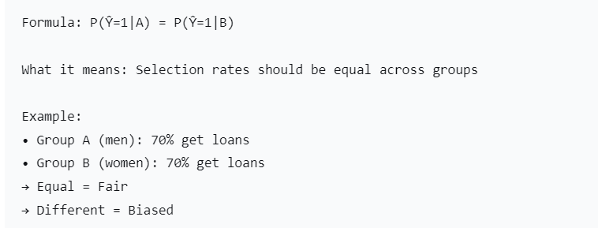
b) Equal Opportunity
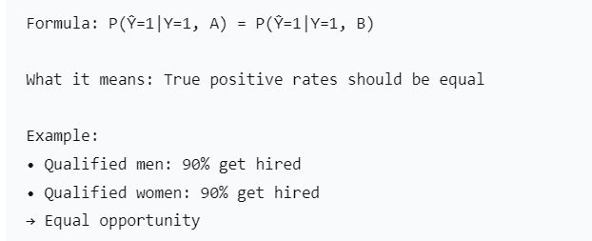
c) Equalized Odds
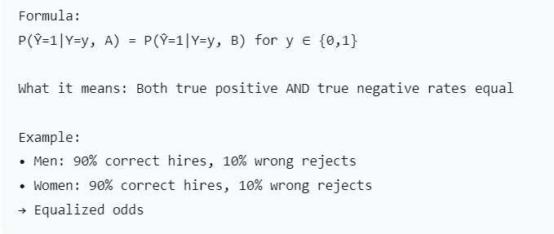

d) Disparate Impact Ratio
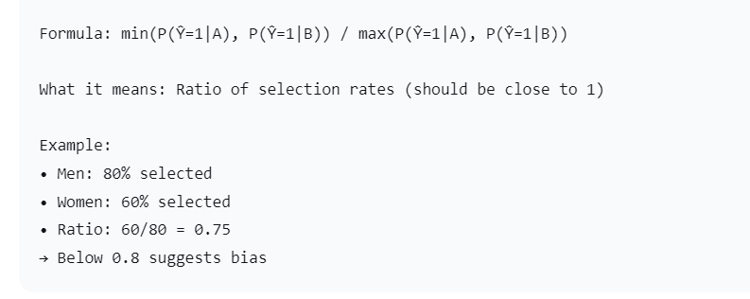
2. PRIVACY METRICS & FORMULAS
Key Symbols:
- k = Minimum group size for anonymity
- l = Minimum distinct values in group
- QI = Quasi-identifiers (can identify people when combined)
- SA = Sensitive attribute (what we want to protect)
Privacy Guarantees:
  - k-Anonymity

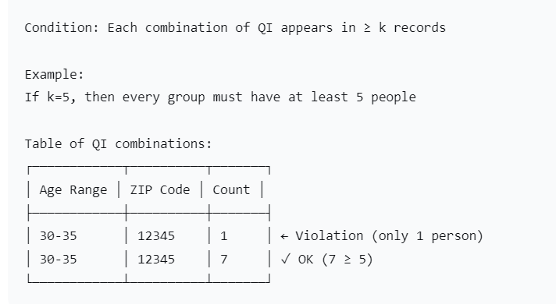

b) l-Diversity
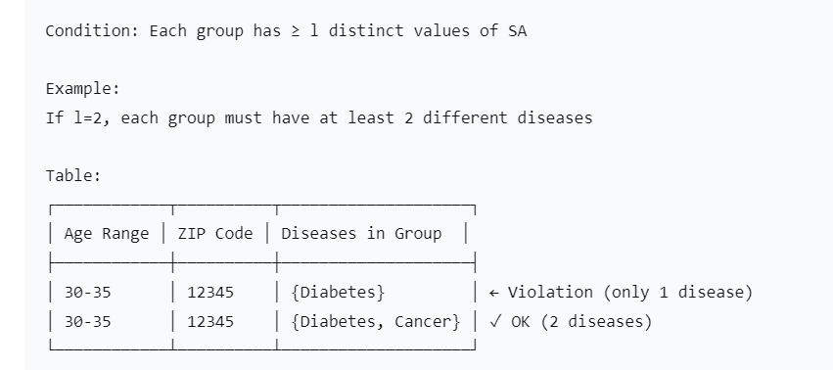
3. TRANSPARENCY METRICS & FORMULAS
Key Symbols:
- F = Feature importance score
- C = Confidence/Probability score
- R = Relevance score
- S = Similarity score
- E = Explanation

Explainability Metrics:
  - SHAP (SHapley Additive exPlanations) Values
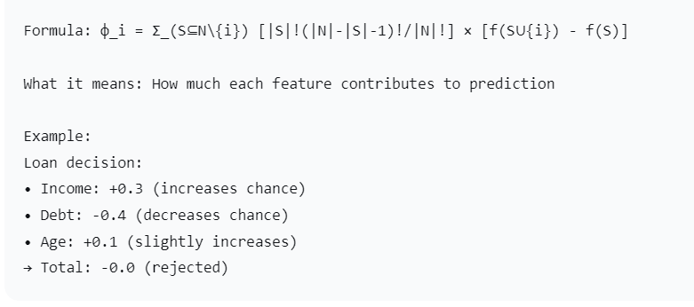

b) LIME (Local Interpretable Model-agnostic Explanations)
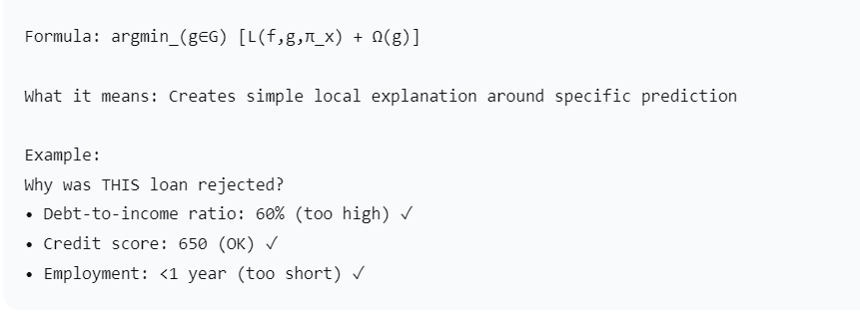
4.The term “RE” in the title should be updated to a term that reflects a phase after system analysis, rather than Requirement Engineering.
Requirement Engineering (RE) is not the implementation itself. In our research, RE is used to define, structure, and validate ethical requirements before and during AI system development, while datasets and models are used only to validate those requirements, not to replace RE.
This research treats Requirement Engineering as a design-time activity, where ethical requirements are elicited, analysed, and specified prior to AI system development. Machine learning models and benchmark datasets are employed solely to validate these requirements and provide empirical evidence of compliance, without violating the classical RE lifecycle.
- RE defines ethical constraints first.
- Datasets are used to validate requirements.
- Models act as test subjects.

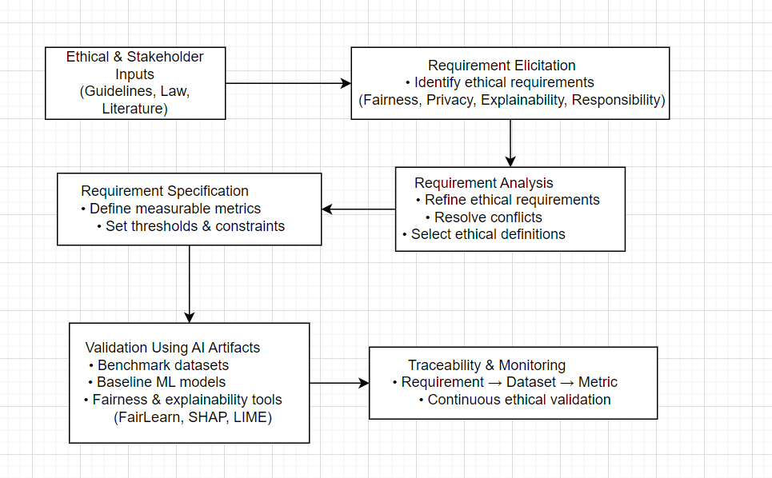

5. Clearly define the scope of the proposed system, including:
• The types of datasets being used
• The models that will be evaluated or verified
Types of Datasets Being Used
This research uses publicly available benchmark datasets that are commonly employed in studies on fairness, bias, and ethical evaluation of AI systems. These datasets contain sensitive attributes (such as gender, age, or race) and decision labels, making them suitable for validating ethical requirements defined during the Requirement Engineering (RE) process. The datasets are used only for validation purposes, not for requirement elicitation.
The types of datasets used include:
- Socio-economic Decision Datasets
These datasets represent real-world decision-making scenarios such as income prediction, credit approval, and marketing responses. They are used to evaluate fairness, accountability, and transparency in AI decision systems.
- Bias-Sensitive Classification Datasets
These datasets explicitly include protected attributes and are widely used to study algorithmic bias and discrimination. They enable the measurement of fairness metrics and validation of fairness-related requirements.
- Benchmark Ethical AI Datasets
Standard datasets adopted by the research community for testing ethical AI frameworks. Using benchmark datasets ensures reproducibility and comparability with existing research.
- Structured Tabular Datasets
All datasets are structured (tabular) and suitable for applying classical machine learning models and fairness evaluation tools.
Why These Dataset Types Are Appropriate
- They support quantitative measurement of ethical requirements
- They include protected attributes needed for fairness analysis
- They are public, well-documented, and reproducible
- They align with the goal of validating ethical requirements defined in RE

Models That Will Be Evaluated or Verified
In this research, baseline and interpretable machine learning models will be evaluated to verify whether the predefined ethical requirements (fairness, privacy, explainability, and responsibility) are satisfied. The models are not proposed as novel AI algorithms but are used as validation instruments within the Requirement Engineering (RE) framework.
The models selected for evaluation include:
- Logistic Regression
Used as a transparent and interpretable baseline model. It enables easy analysis of feature influence and supports explainability and fairness evaluation.
- Decision Tree Classifier
Provides rule-based decision logic that is naturally interpretable. It is useful for validating explainability and accountability requirements.
- Random Forest (Baseline Ensemble Model)
Used to study trade-offs between accuracy and ethical requirements such as fairness and transparency.
- Support Vector Machine (Linear Kernel)
Applied to assess ethical compliance in more complex decision boundaries while maintaining partial interpretability.
Purpose of Model Evaluation
- To verify ethical constraints defined during the RE phase
- To compare ethical trade-offs across different model types
- To provide quantitative evidence for requirement validation
- To demonstrate how ethical requirements can be monitored across models
Models Suitability
- Widely used in ethical AI and fairness research
- Compatible with fairness and explainability tools (FairLearn, SHAP, LIME)
- Computationally efficient and reproducible
- Appropriate for research focused on validation, not model innovation
Important Clarification
The selected models serve as test subjects to validate ethical requirements and do not represent the core contribution of this research.

6- The problem statement should be revised to remove Requirement Engineering, as it does not appropriately fit in this section.
The Word RE is the main alignment of my Research paper. As I already addressed in question 4.

7- All-important terms used in the problem statement should be justified and supported by relevant example.
1. Requirement Engineering (RE) methods don't properly capture ethical needs
Easy meaning: We write down what the AI should DO but forget to write down what the AI should BE.
Like building a car:
- We write: "Car must go 100 mph" (what it should DO)
- We forget: "Car must not crash into people" (what it should BE)
For AI:
- We write: "AI must approve loans quickly"
- We forget: "AI must be fair to all races and genders"

2. Ethical needs: accountability, privacy, explainability, fairness
Accountability = Who's responsible when AI messes up?
- Easy example: If a self-driving car crashes, who's responsible?
  - The car company? The programmer? The owner?
  - Currently: Everyone says "not me!"
Privacy = Keeping secrets safe
- Easy example: A health app should keep your medical info private
- Currently: Apps often share data without clear permission
Explainability = AI should explain its decisions
- Easy example: If a loan is denied, the AI should say WHY
- Currently: AI often says "no" without explanation
Fairness = Treating everyone equally
- Easy example: A hiring AI should not prefer men over women
- Currently: Many AI systems show bias

3. "Ethical standards are theoretical and lack metrics"
Theoretical = Just ideas, not rules
- Easy example: We all agree "be fair" but nobody says HOW fair
- Like saying "be a good driver" but not defining what that means
Lack metrics = "No numbers to measure"
- Easy example:
  - Bad: Be fair (How do we measure this?)
  - Good: Hire equal percentages of men and women (±5%)
  - Currently: We have the "bad" version, not the "good" version

4. Lack tool support
Easy meaning: No software tools to check if AI is ethical
Like building without a measuring tape:
- Builder: Is this wall straight?
- Current: I think so, looks okay
- Needed: Let me check with a level
For AI:
- Developer: Is our hiring AI fair?
- Currently: I think so, we tried
- Needed: Let me run the fairness checker

5. Lack lifecycle traceability
Lifecycle = From idea to thrown-away
- Easy example: Like tracking a car from design → factory → road → junkyard
Traceability = Following the breadcrumbs
- Easy example: If food makes you sick, you trace it back to the farm
- For AI: If AI is unfair, can we trace WHY?
  - Bad data? Bad programming? Bad testing?
  - Currently: Hard to trace, like finding a needle in a haystack

9- Dataset information must be properly explained and linked with the justification of the models used, since the system relies on both datasets and models for its operation.
Ethical Requirement | Best Dataset-Model Pair | Why This Pair Works
Fairness | COMPAS + Random Forest | RF's feature importance reveals racial bias patterns
Transparency | German Credit + Decision Tree | Tree rules show exactly why loans are approved/denied
Explainability | UCI Adult + Logistic Regression | Coefficients translate to "age increases income chance by X%"
Accountability | Lending Club + All Models | Multiple models provide cross-validation for audit trails

Use Case | Dataset | Model | Ethical Focus
Loan Fairness Audit | German Credit | Logistic Regression | Fairness (coefficient bias)
Hiring Transparency | UCI Adult Income | Decision Tree | Transparency (clear rules)
Medical Bias Detection | COMPAS | Random Forest | Fairness & Explainability
Marketing Accountability | Bank Marketing | All three | Comparative ethics analysis

